ASSIGNMENT 1
- Write a C program to add two integers.
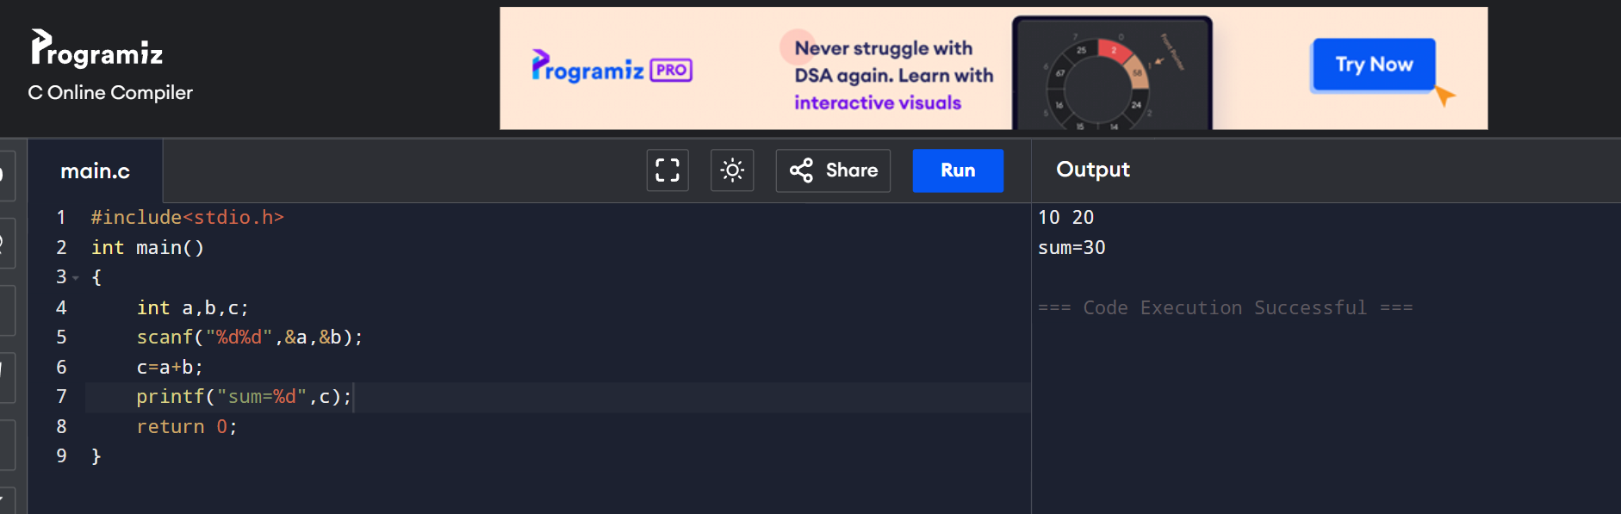

- Write a program to swap two numbers using a temporary variable.
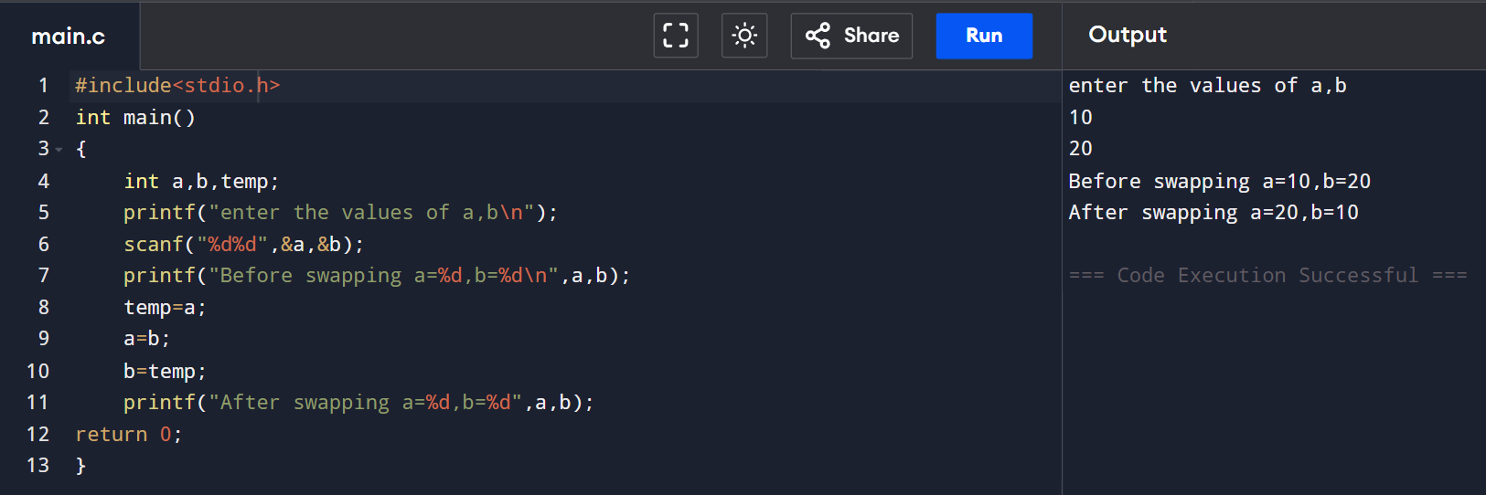
3. Write a program to swap two numbers without using a temporary variable.
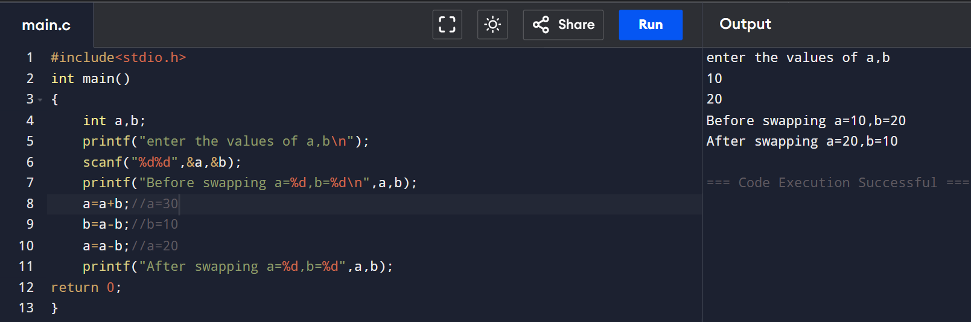
4. Write a program to compute the simple interest.
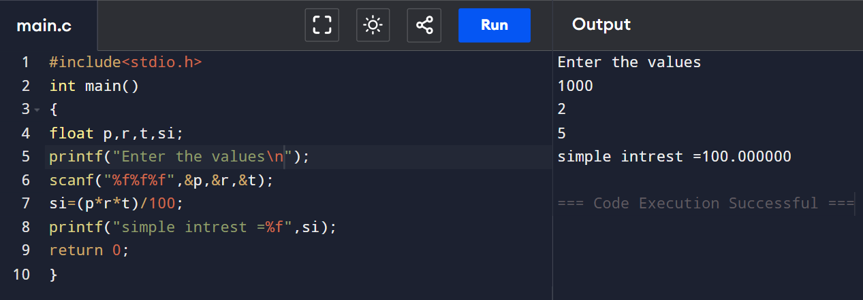

5. Write a program to convert temperature from Celsius to Fahrenheit.
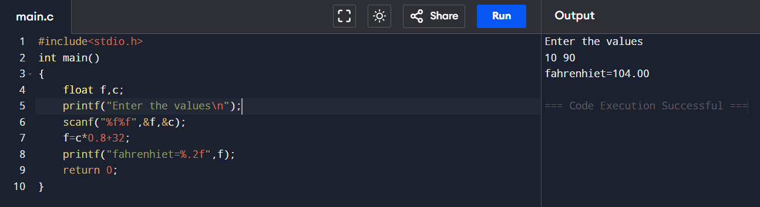

6. Write a program to find the quotient and remainder of two integers.
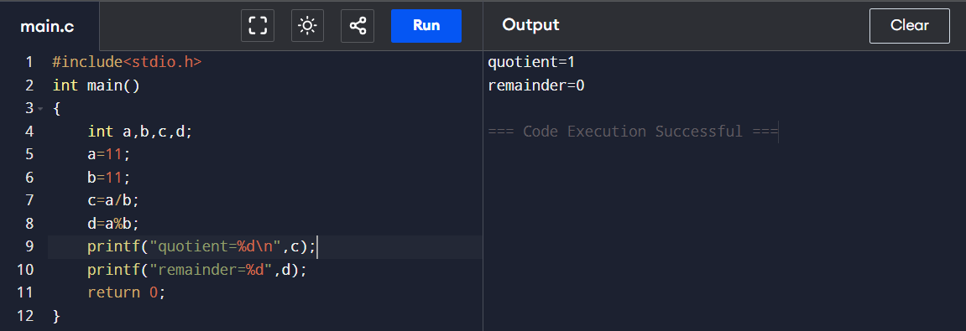
7. Write a program to check whether a number is even or odd.
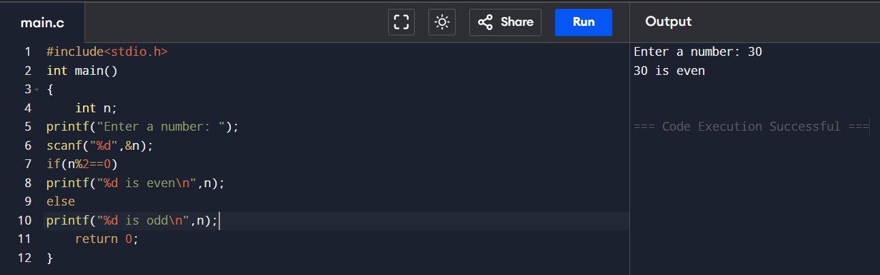
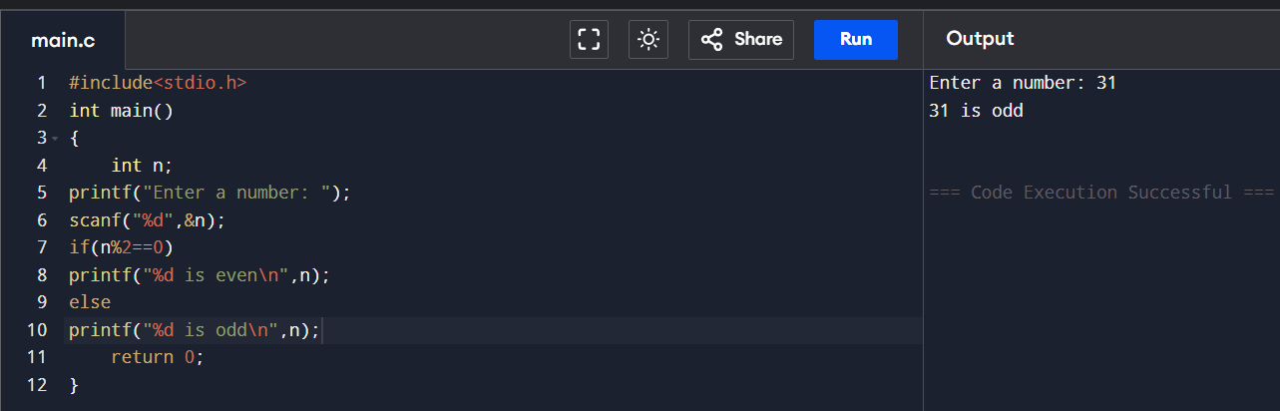

8. Write a program to find Roots of a Quadratic Equation ax2 + bx + c = 0
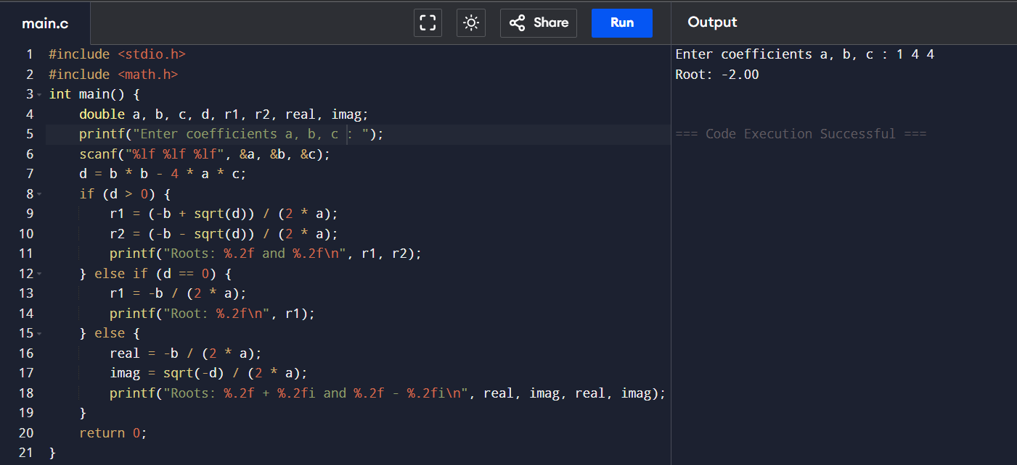
9. Write a program to calculate the square and cube of a number.
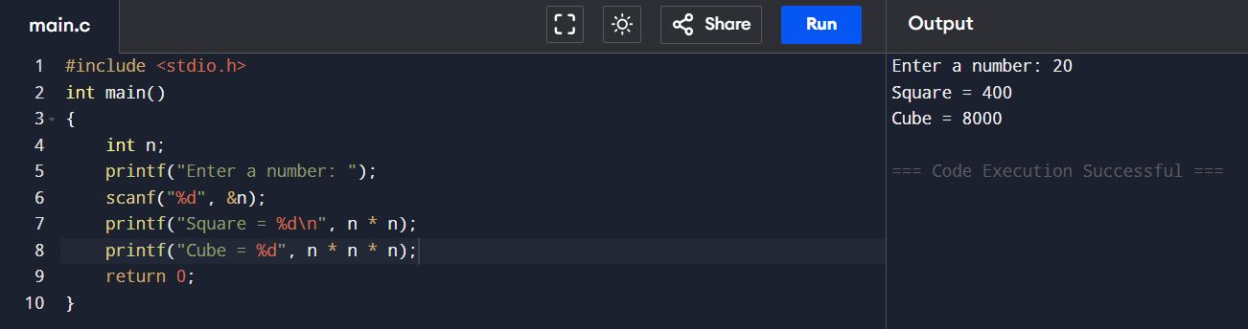
10. Find the largest number among three numbers.
